1. Here is the github link. <https://github.com/Ariyune/Rate-Of-Fuel-Project.git>
2. The updated code coverage report is inside **html2.rar** this time, but it is similar to the last one since we’ve finished up the project in the last submission.
3. 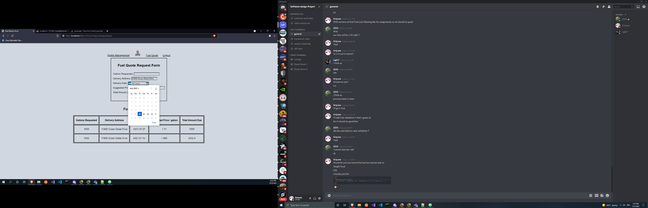This time, Danny Phan was responsible for the creation of the ajax calls, get quote button, and the functionality of it (being disabled until user inputs information, etc.). The pricing module was built by Dong Nguyen and the certain functions like pulling the state information from the profile display was done by Carlos. Since all the portions were somewhat integrated, the team members gave Danny Phan their parts to fully incorporate into the fuelquote.php and other php files that I was responsible for. Therefore the main push to github was made by Danny Phan.

ADDED PREVIOUS DATE RESTRICTION (CAN’T ENTER PREVIOUS DATES FROM CURRENT DATE: 7-27-21)